**LAB 11**

**CHI-SQUARED TEST**

**Aim: To conduct Chi Aquared Test**

**New-Term:**

1. **dbinom(): This function is used to calculate the probability mass function (PMF) of a binomial distribution. It calculates the probability of obtaining a specific number of successes in a fixed number of independent Bernoulli trials. In the code, it is used to calculate the expected frequencies (exf) based on the binomial distribution with parameters n (number of coins), p (probability of success), and N (total number of tosses).**
2. **qchisq(): This function is used to calculate the quantile function (inverse cumulative distribution function) of a chi-square distribution. It calculates the value corresponding to a given probability or percentile. In the code, it is used to calculate the critical value (tv) for the goodness-of-fit test.**
3. **chisq.test(): This function is used to perform a chi-square test in R. It tests the independence between two categorical variables using a contingency table. In the code, it is used to perform the chi-square test (chisq.test(data)).**

**Input:**

**#APPLYIGN CHI SQUARE TEST FOR GOODESS OF FITNESS AND CONTINGENCY TEST TO REAL DATASET**

**#Goodness of fit**

**#Number of coins**

**n=5**

**n**

**#Level of significance**

**alpha=0.05**

**#Total number of tosses**

**N=256**

**p=0.5**

**p**

**x=c(0:n)**

**x**

**obf=c(5,35,75,84,45,12)**

**exf = c(dbinom(x,n,p)*256)**

**#Check the condition if sum of observed equals sum of expected**

**sum(obf)**

**sum(exf)**

**#Output using Chisq - distribution**

**chisq=sum((obf-exf)^2/exf)**

**chisq**

**cv = chisq**

**#Tabular value**

**tv = qchisq(1-alpha,n);**

**tv**

**#Hypothesis Conclusion**

**if(cv <=tv)print("Accept H0/Fit is good")else print("Reject H0");**

**#Q2**

**#Independent attributes**

**#Input the data**

**data <- matrix(c(69,51,81,20,35,44),ncol=2,byrow=T)**

**data**

**#Number of data**

**l=length(data)**

**l**

**#Output by chi square distribution**

**cv = chisq.test(data)**

**cv**

**#p-value**

**cv=cv$p.value**

**#Hypothesis conclusion**

**if(cv>alpha){print("Attributes are indepenedent")}else{print("Attributes are dependent")}**

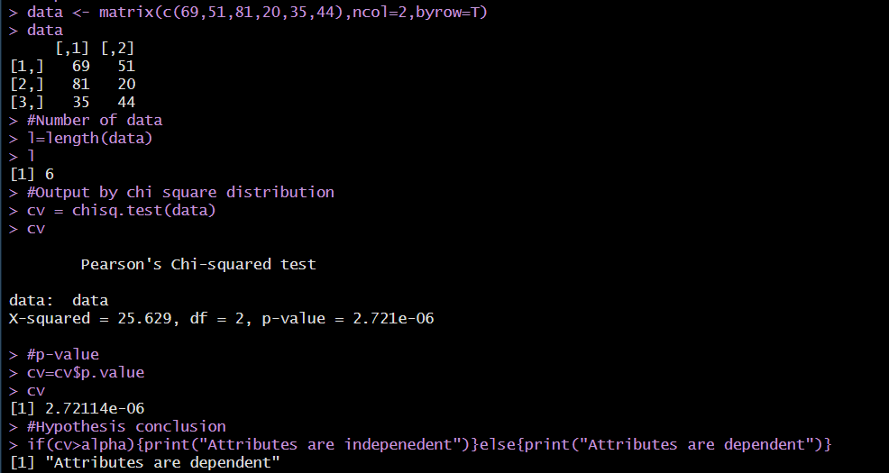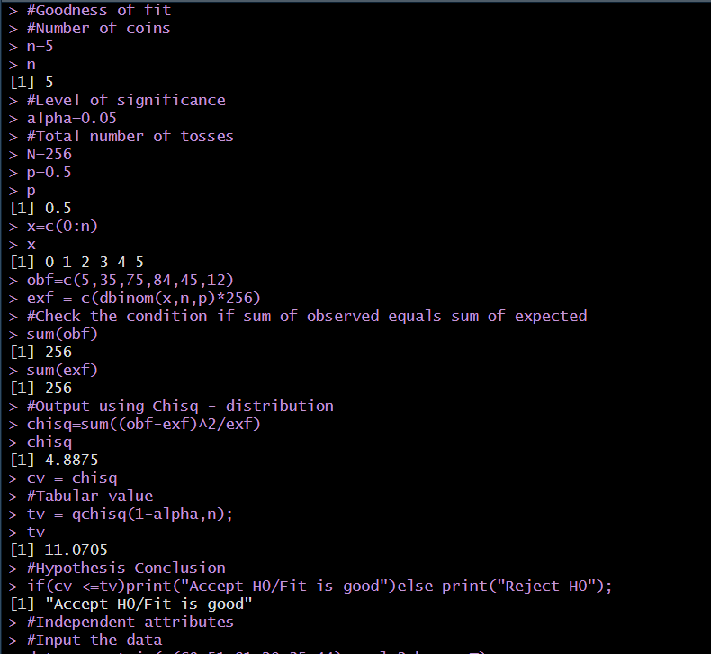**OUTPUT:**

**Inference:**

**If the cv>tv then chi square test H0 hypothesis is accepted or else it H0 is not accepted.**

**\*\*\*\*\*\*\*\*\*\*\*\*\*\*\*\*\*\*\*\*\*\*\*\*\*\***